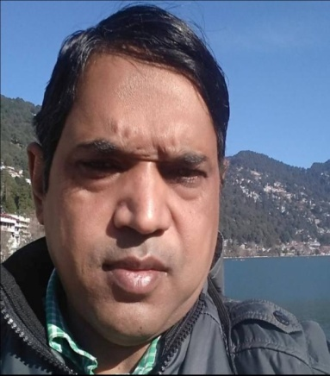 RESUME
Name Dilnawaz Ahmad

Address Flat no. S1, Building no. B1/151 DLF, BHOPURA
Shahibabad, Ghaziabad pincode - 201005
Contact Mobile no. 9312618642
EMAIL dilnawazahmad755@gmail.com Qualifications MBA from APJ Abdul Kalam tech. University, Lucknow, U.P. – (2002)
Specialize Area Marketing and HRM
Graduation: Bachelor of Arts (Honors) from A.M.U. Aligarh (U.P.) – . 2000

Experience ( 1) 16 years of experience in retailing, marketing, branding and sourcing of . Office Automation products viz; photocopier machines, laser printers and
Its accessories.
Designation Sales executive and senior sales executive
Job Profile Toured many cities of states like Jammu and Kashmir Himachal Pradesh, . Haryana, U.P, M.P, Rajasthan, Gujarat, Chhattisgarh, Orissa, Bihar, Jharkhand,
Kerala and Major Cities like Mumbai, Bangalore, Pune and Chennai from . Location of my office in New Delhi for Business development.
Job profile includes sales and marketing, price negotiation, collection of . Payment, Settlement of account and market research.
During this period have work with RANK OFFICE AUTOMATION PRIVATE . LIMITED NEW DELHI, PERFECTION OFFICE EQUIPMENT . NEW DELHI and FRIENDS INTERNATIONAL NEW DELHI
EXPERIENCE(2) 2 YEARS OF EXPERIENCE IN INDISTRIAL SAFETY PRODUCTS.
DEGISGNATION BUSSSINESS DEVELOPMENT MANAGER
JOB PROFILE MARKETING OF INDISTRIAL SAFETY GLOVES, FINGERS AND . EAR PLUG ON PAN INDIA LEVEL, JOB PROFILE INCLUDE . TELECALLING, TOURING, COLLECTION OF PAYMENTS, . SETTLEMENT OF ACCOUNTS AND MARKET RESEARCH
PRESENTLY WORKING WTH VIRMANI SAFETY PRODUCTS NEW . DELHI
PERSONAL PROFILE GENDER – MALE
DOB – 25TH SEPT 1978
MARITAL STATUS – MARRIED
NATIONALITY – INDIAN
LOCATION – NEW DELHI
FATHER’S NAME – MR. SHAKIL AHMAD
LANGUAGES KNOWN – ENGLISH AND HINDI

